Laurens County Schools World History Curriculum Map
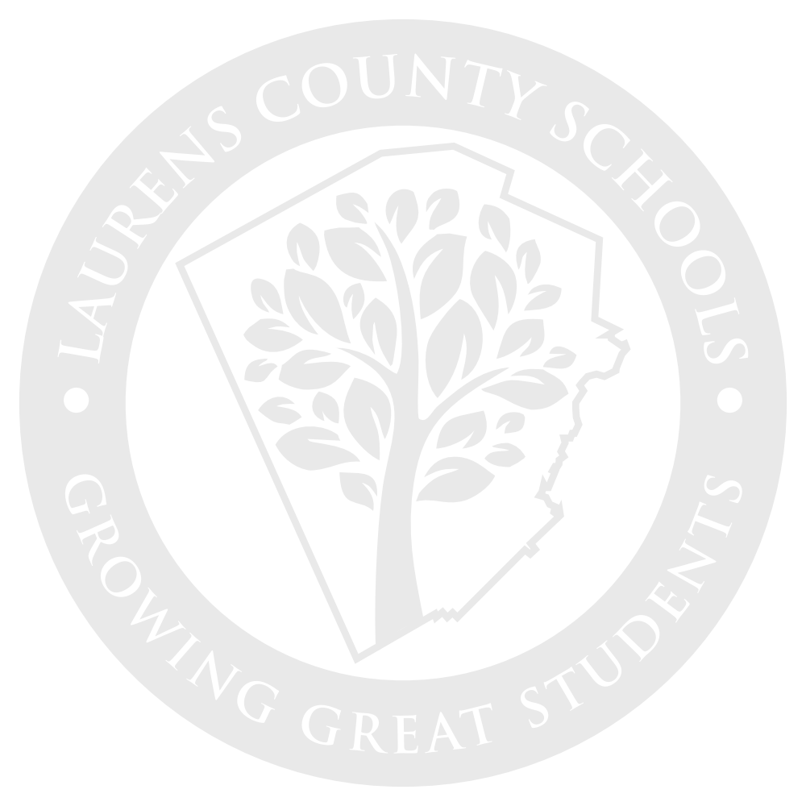
 | 1st 9 Weeks | 2nd 9 Weeks | 3rd 9 Weeks | 4th 9 Weeks
Units/Standards | Unit 1: Themes  ____________________  Unit 2: Ancient Civilizations SSWH1,2  ____________________  Unit 3: Classical Med. Empires SSWH3,4 | Finish Unit 3  ____________________  Unit 4: Africa & middle East & Islam SSWH5, 6, 12  ____________________  Unit 5: Middle Ages, Renaissance & Reformation SSWH7, 9, 10 | Finish Unit 5  ____________________  Unit 6: Americas & Exploration SSWH8, 10  ____________________  Unit 7: Scientific Rev., Enlightenment, & Revolutions SSWH 13, 14 | Unit 8: Industrialization, Urbanization, Nationalism & Imperialism  SSWH 15, 16  _____________________  Unit 9: WW1, Interwar Period, WW2 SSWH17, 18, 19  _____________________  Unit 10 Cold War, World Since 1960s & Globalization SSWH 20, 21, 22
Special Assignments and/or Performance Assessments |  | Middle Ages Choice Board (church) | Columbian Exchange Activity  Exploration Choice Board
Readings  (Excerpts) | Epic of Gilgamesh  Mahabharata  Exodus  Analects  The Republic  The Politics  The Edicts | The Quran  The Prince | Bernal Diaz (Cortez)  English Bill of Rights  Magna Carta  Two Treatises of Government  Social Contract  Dec. of Rights of Man & Citizen | Charles Dickens (Hard Times)  All Quiet on Western Front  Gandhi  Universal Human Rights  Mao Zedong
Gifted/Honors | Children’s Book Performance Assessment  Portfolio  (culminating) | Fishbowl-Mongol Debate  Manor Activity  Portfolio-part 1 due  Renaissance Menu | Revolution Activity  Portfolio | World War Activity  Portfolio part 2 due  (culminating)

