With all of the recent challenges, are you wondering what are some of the best resources to keep your student on track for academic success?
This is a more concise list of just some of the online instructional resources that can help keep your student prepared for the next grade level and fill in some of the instructional gaps being caused by schools having to close early. These sites serve as more of a One-Stop-Shop for multiple grade levels and subject areas.

For a more comprehensive list of many more resources, visit our school district’s curriculum and instruction website: https://lcsscurriculumandinstruction.weebly.com/

- Laurens County Students’ Clever Account Apps and Resources will still be available to students: https://clever.com/oauth/authorize?channel=clever&client_id=4c63c1cf623dce82caac&confirmed=true&district_id=58138a9c20b7ff0100000060&redirect_uri=https%3A%2F%2Fclever.com%2Fin%2Fauth_callback&response_type=code&state=6cd9adb8e0befd2f11afc59dd6f2e01ce1148993f0c4d445e33cf193941678fa

- As part of the public media mission to ensure all kids have access to continued free educational resources at home, GPB, in partnership with Georgia Department of Education is offering broadcast programming and accompanying PreK-12th Grade digital resources that adhere to Georgia’s state standards. https://www.gpb.org/education/learn

- Day by day projects to keep PreK-9th Grade kids reading, thinking, and growing. Scholastic Learn At Home https://classroommagazines.scholastic.com/support/learnathome.html

- Per-K through High School Parents, Georgia Power’s Learning Power program is here for you! We’ve launched our Learning Power Mobile Game App to go along with our STEM-based classroom energy lessons, all aligned with the Georgia Standards of Excellence. http://www.learningpower.org/georgia.html

- Preparing your PreK student for kindergarten is vitally important. See this site for daily activities, screen free time, outside time story time, and virtual field trips that will start your child’s academic career off on a firm foundation, not behind. http://www.decal.ga.gov/PreK/WelcomeToGAPreKAtHome.aspx

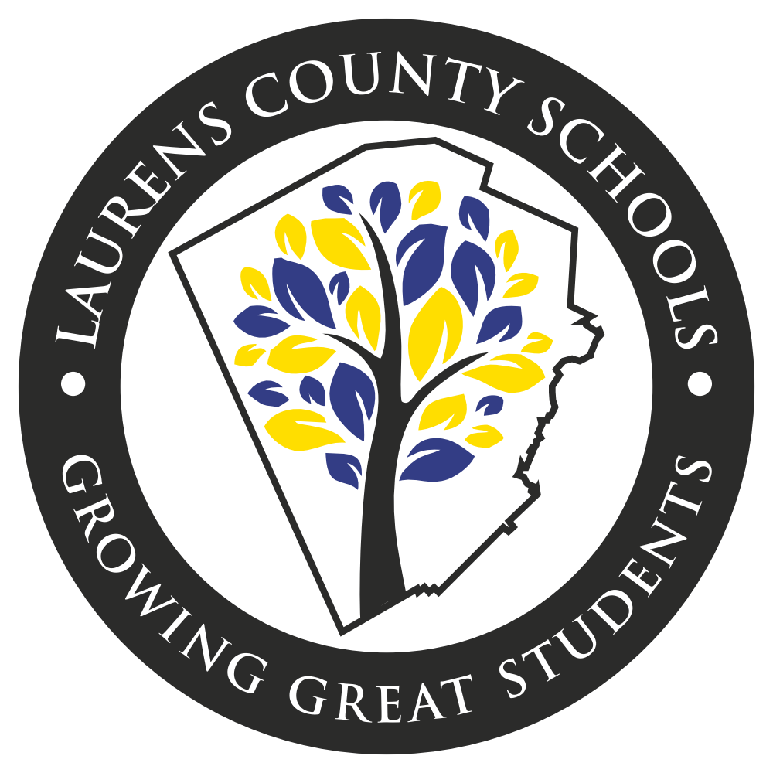
Throughout the summer, be sure to continue visiting your teacher’s Google Classroom and other online learning platforms they created for you.

Most importantly, have fun and keep growing!

