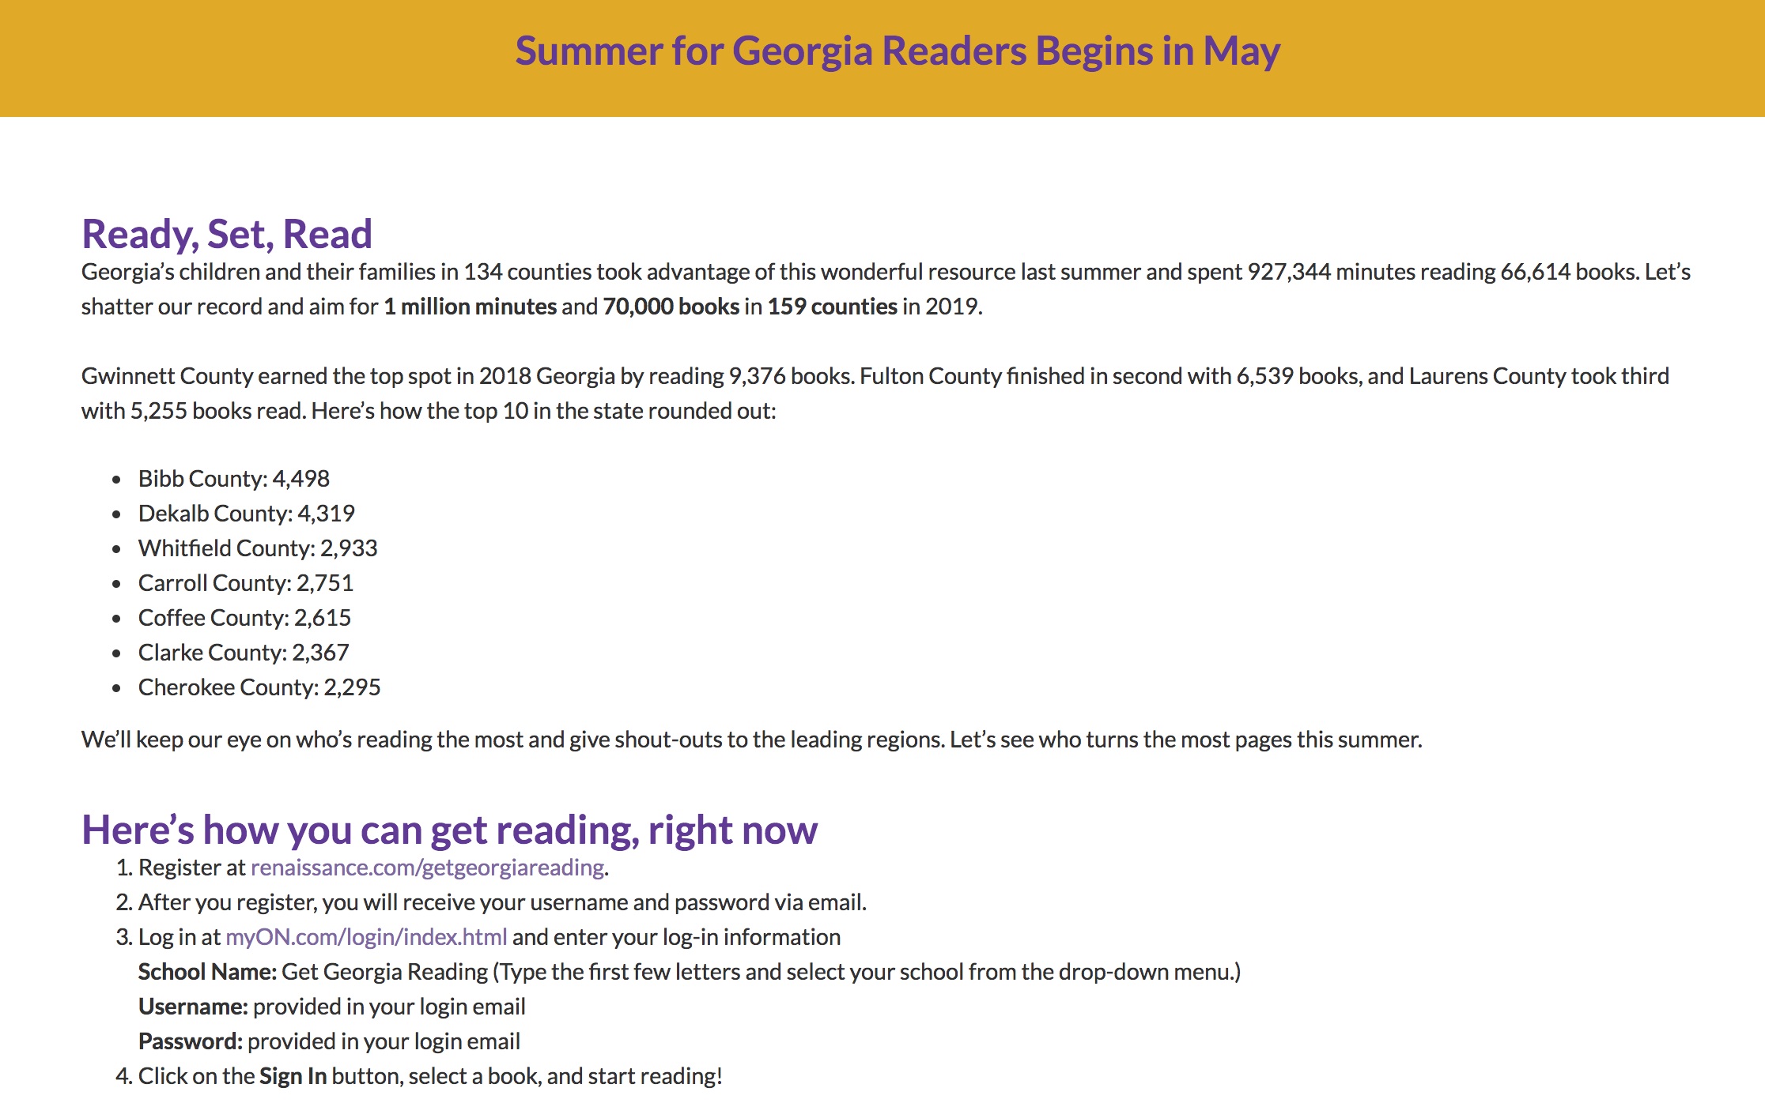
Laurens County had students reading last summer using MyOn. Let’s do it even better this summer! Please make sure our parents are aware of the free access they have once again this summer to MyOn.

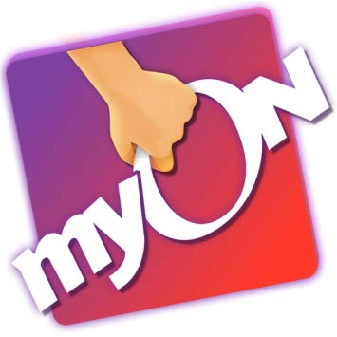
You can read anywhere, anytime, and virtually anything this summer, because Get Georgia Reading partner Renaissance MyON is delivering thousands of free books—plus engaging daily news articles—to your computer and mobile devices that you can access 24 hours a day from May 6 through Aug. 31.
All children, parents and guardians, educators, and librarians can search from more than 50 different categories and genres, fiction and nonfiction, picture books, graphic novels, chapter books, titles for struggling and reluctant readers, and Spanish and bilingual titles.
It’s like having your own personal library right at your fingertips.

Here’s how you can get reading, right now
- Register at renaissance.com/getgeorgiareading.
- After you register, you will receive your username and password via email.
- Log in at myON.com/login/index.html and enter your log-in information
School Name: Get Georgia Reading (Type the first few letters and select your school from the drop-down menu.)
Username: provided in your login email
Password: provided in your login email
- Click on the Sign In button, select a book, and start reading!

