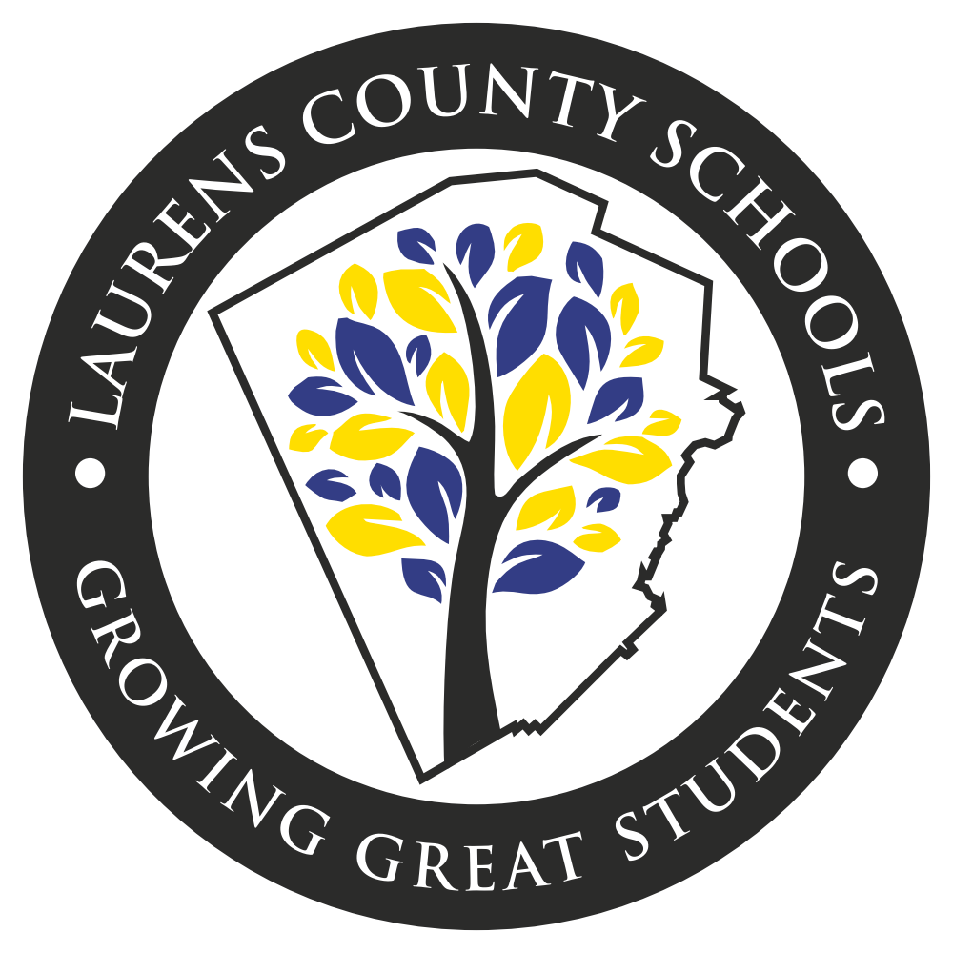

The growth and development of people is the highest calling of leadership.
~Harvey Firestone

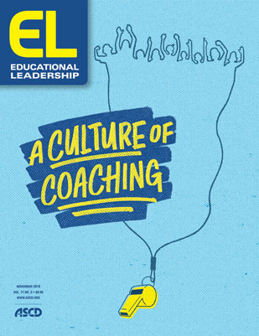
Laurens County Schools
2021-2022
Professional Learning Plan

Table of Contents
The Students Success Model…………………………………………………………………….3
Definitions of a Professional Learning Community……………………………...……………4-5
Laurens County School Professional Learning Groups……………………………..…………..5
Aspiring Leaders………………………………………………………………………………..6
Principals Professional Development…………………………………………………………..7
Assistant Principals Professional Development………………………..……………………….8
District-Wide Alignment ………………………….……………………………………………9
Media Specialists Community of Learners…………………………………………………….10
District Data Team and Registrar Sessions…………………………………………………….11
New Teacher Induction…………………………………………………………………………11
Professional Learning for Teachers of LMB, and SPED…………………….…………………12
Instructional Coaches TEAM…………………………………………………………………..13
ESOL Professional Learning……………………………………………………………………14
Gifted/MTSS/PBIS………………………………………………………………………………15
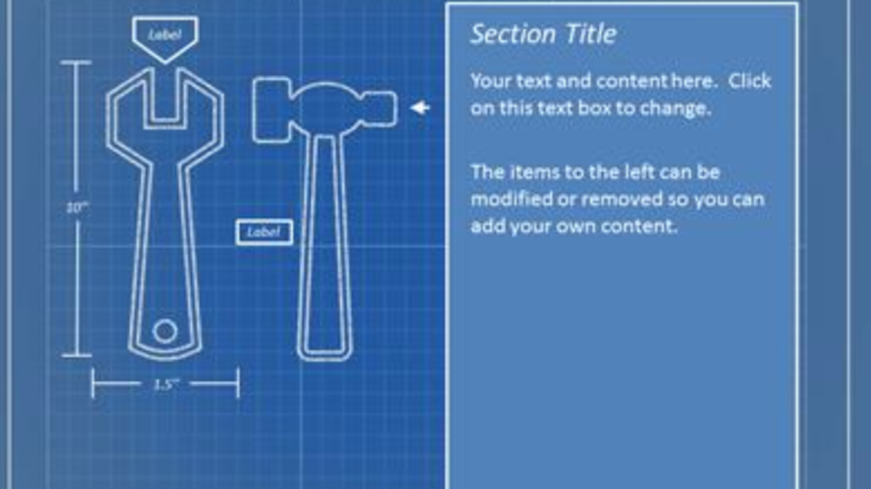
District-Wide Professional Learning Dates……………………………………….…………….16
DISTRICT IMPROVEMENT GOALS
- To increase number of students reading on grade level based on Lexiles.
- Increase number of students in ELA and Math scoring on the GMAS at a proficient or distinguished level to pre-COVID percentiles.
2a. Teach students to conceptualize/rationalize the math rather than teaching them to simply memorize the math.
2b. Implement the findings and practices of the Science of Reading with the teaching of reading.
- To close the achievement gaps within the subgroups.
- Increase and/or maintain school climate ratings at each school.
District-Wide Professional Learning Sessions………………………………………………….17
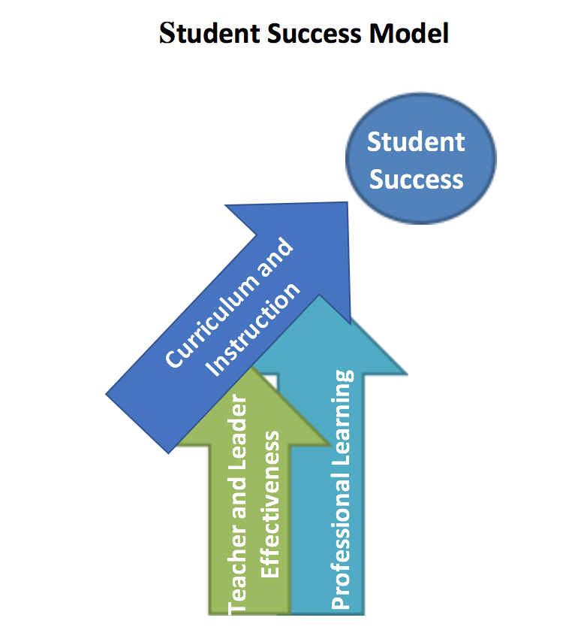

The Georgia State Board of Education defines Professional Learning as: “the means by which teachers, administrators and other school and system employees acquire, enhance and refine the knowledge, skills and dispositions necessary to create and support high levels of learning for all students.” This definition defines students’ success as the ultimate outcome of intentional and purposefully planned professional learning. The vital role of professional learning is more clearly illustrated with the following graphic borrowed from the Kentucky Department of Education.
Professional learning occurring within a LUA or any organization that requires employees to be certified will be job-embedded and will take place within a Professional Learning Community (PLC). The PLC will be the primary vehicle for professional learning. PLCs operate under the assumption that the key to improved learning for students is continuous job-embedded learning for educators (2015). (Retrieved from “All Things PLC” http://www.allthingsplc.info/about.) Workshops, when needed, will support the work of job-embedded professional learning done within learning communities, not replace it.
1. Engaging in professional learning on a continuing basis by fully participating in the LUA’s professional learning community as documented by the educator’s supervisor and described in GaPSC Guidelines accompanying this rule;
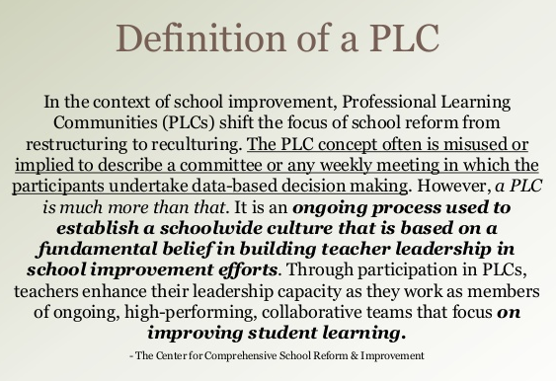

“Turning Best Practice into Common Practice”

In the Laurens County School System, a Professional Learning Community is who we are as a result of several efforts to build a community of learners and where we strive to make best practice, common practice.
Expectations:
- Sessions are engaging and require participation from attendees.
- Attendees are able to see an instructional strategy modeled and/or taught that they can implement in their classroom.
- PLC sessions will continue to transition more toward teacher-led and more toward being differentiated at the school level to meet the unique needs of all educators.
- In addition to the professional development taking place in PLC sessions, school level PLC sessions provide time for teachers to share expertise, analyze student work, plan instruction and collaborate to improve teaching skills and the academic performance of students.
- PLC sessions are routinely taking place including the delivery of the district PLC session each month and at least one school level, school designed session each month.

Topics for FY22 District PLCs will all be centered around The Science of Reading. The sessions will be differentiated for each of the 3 grade spans.

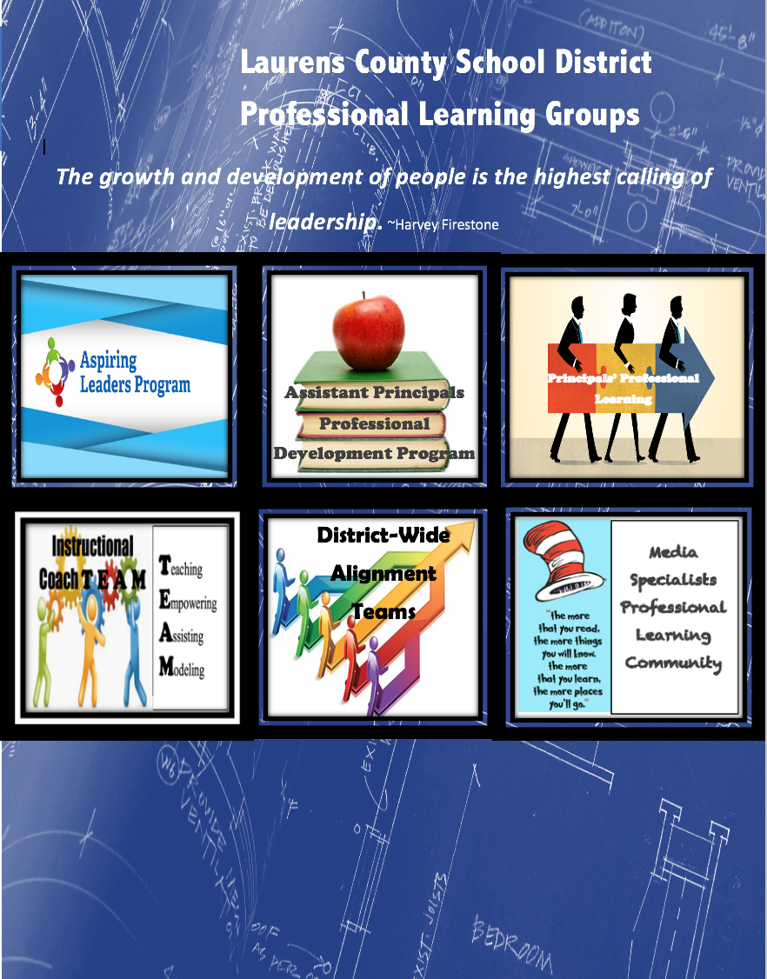

Aspiring Leaders Cohort 7
Session dates will be set throughout the year. *Participation in
Aspiring Leaders is based on principal recommendation, not volunteer.

Session One
Program Overview and Requirements
Advice from Previous Cohort
Who Are Your Partners for the Journey
21 Irrefutable Laws of Leadership Introduction
Leader Styles and Qualities
LKES Overview & Standards 1-4
The Butterfly Effect
Session Two
Word Cloud Presentation
Animal Personalities-Working with Different People
Infomercial Book Study Introduction
Community Literacy Project Introduction
21 Irrefutable Laws of Leadership Continued
LKES Standard 5-Mr. Passmore
LKES Standards 6 &7-Dr. Hall
LKES Standard 8-Mrs. Brock

Session Three
School Finance and Budgeting
Growth Mindset for Leaders
Community Literacy Project Presentations
21 Irrefutable Laws of Leadership Completion
Schedule Time to Visit Leaders
Questions for the Leadership Panel

Session Four
Infomercial Book Study Presentations
Report Out on Visits with Leaders
Interview Tips Activity
Leadership Panel Discussion
Final Leadership Advice

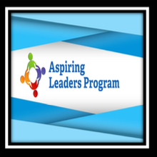

Beginning in the FY22 school year, the second half of each principals’ meeting will be dedicated to the professional growth and development of principals. A great amount of learning will be based on the book, What Great Principals Do Differently. Principals will also participate in “A Deeper Dive” into each of the LKES standards.

August 17-New Math GSE & What Great Principals Do Differently
September 14
What Great Principals Do Differently & LKES 1
October 19
What Great Principals Do Differently & LKES 2
November 16
What Great Principals Do Differently & LKES 3
January 18
What Great Principals Do Differently &, LKES 4 and 5
February 15
What Great Principals Do Differently & LKES 6
March 15
What Great Principals Do Differently & LKES 7
April 19
What Great Principals Do Differently & LKES 8

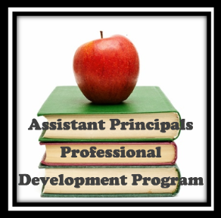

Assistant Principals Sessions:

Assistant Principals will continue to meet the 3rd Thursday morning of every month except December and May
(See dates on page 16.)
Assistant principals filled out a survey of their needs in the last session of the FY21 school year. In response to those survey results, assistant principals will participate in peer observations during the FY22 school year. They will also have time to collaborate among themselves in a whole group session.
Sessions will also include a book study designed specifically for the role of assistant principals and the leadership needed for principalship.
Melissa Cutler will provide a session “Aspen for Assistant Principals,” and Stacey Sanders will provide a session regarding coteaching.

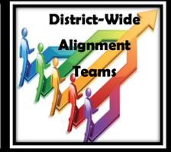

Four years ago, the Laurens County School District began an epic journey to improve the instructional practices for our students. This journey is called District Wide Alignment (DWA). The vision of the Laurens County DWA teams is to develop curriculum maps and common assessments that are aligned to those curriculum maps. These maps and assessments are 100% designed and vetted by Laurens County teachers. The purpose of the DWA is to level instruction for all Laurens County students. We believe that if a student attends any school in our county, they should receive the same quality education in the same scope and sequence. Not only do our teams develop comprehensive curriculum maps but they also spend quality time aligning standards to proper rigor levels. Aligning district purchased instructional resources to the LCSS curriculum map is also a goal of the DWA teams.
At present, the Grades K-12 ELA team have their initial curriculum maps and are working to add embedded writing instruction to the map. This team is also working to complete unit benchmarks that will reflect the core developmental standards of ELA. The Grades 3-12 Math teams have completed their curriculum maps and implemented unit benchmarks thru the Performance Matters platform. All curriculum maps and unit benchmarks will be reviewed on a quarterly basis by the DWA teams. These are living, breathing documents that adjust to needs of our students.
Picking DWA Back Up and Furthering the Work
Future plans for the FY22 school year include Associate Superintendents of Curriculum and Instruction having an initial planning session with each of the teams currently in the process of District-Wide Alignment. After these groups are well established and underway in the FY22 school year, the associate superintendents intend to expand the alignment groups to other grade spans and subject content areas. Associate Superintendents of Curriculum and Instruction will continue to work with the Federal Programs office team to continue the quarterly meetings with established teams for collaboration purposes and continued alignment. The next alignment group will be K-2 Math to complete the Math curriculum.

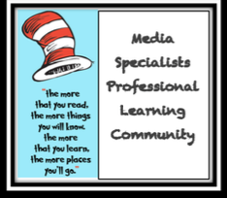

Media Specialists Meetings

August 30, 2021 1:00 ELMS
Professional Learning Overview
Register for 3 Sessions with HGRESA
Begin Development of Evaluation for Media Specialists
October 25, 2021 1:00 ELPS
Follow Up from HGRESA September Session
Development of Evaluation for Media Specialists
January 31, 2022 1:00 SWLE
Follow Up from HGRESA November Session
Development of Evaluation for Media Specialists
April 25, 2022 1:00 NWLE
Follow Up from HGRESA February Session
Development of Evaluation for Media Specialists

A great amount of the professional learning for media specialists will be focused on further development of the new services and resources provided in our media centers. A laser focus will continue to be placed upon making the media centers more relevant for today’s learners and today’s teachers. This work will be informed by the “We Believe” document created by the media specialists within the school district.

HGRESA is offering 3 sessions with the GADOE Media Specialist Liaison Donna Hinkley and Ana Daughtry
September 14 8:30-12:30
November 18 9:30-11:30
February 15 9:30-11:30

Student Record
Student Class
CPI
FTE
CCRPI

District Data Team Meetings and Registrar Sessions

In an effort to further align all the data collection and reporting responsibilities for Laurens County, the District Data Team and Registrar Training sessions were developed. The District Data Team is comprised of district level leaders, directors, and data collection clerks. The purpose of this team is to maximize data reporting opportunities, including budgeting and resource allocations, as well as the data that is released to the public.
District Data Team meetings are currently scheduled for the months of September, November, and February. Trainings and planning sessions will continue throughout the year with registrars as well.
The more we know about the many, intricate details of each of the data reporting pieces, the better able we will be to serve our students.
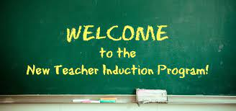

Teachers who are new to the profession or new to the Laurens County School District will participate in the New Teacher Induction Program.

New Teacher Orientation: July 30
November-Breakout Sessions Based on Survey Results
January-Know Your Impact, TKES, Who Teaches Reading?
April-Further Supports Available for New Teachers

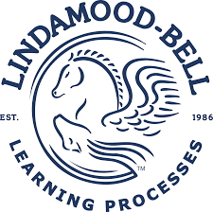
LMB coaching and training will be provided in-house at the elementary and middle school level by a teacher leader who is well trained in LMB processes.

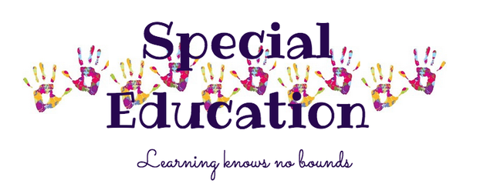
To assist with the goal of further differentiating PLC sessions for specific content and teaching assignment needs, the Special Education department has created the following sessions and professional learning opportunities.

Monthly, the special education department will utilize a hybrid approach of train the trainers (lead special education teachers to redeliver) and also direct professional learning from the district special education leadership team.

Training for our adaptive classes will be provided by a local board certified behavior analyst.

New special education teachers will participate in a New Special Education Teacher Induction Program supported by GaDOE/GLRS.

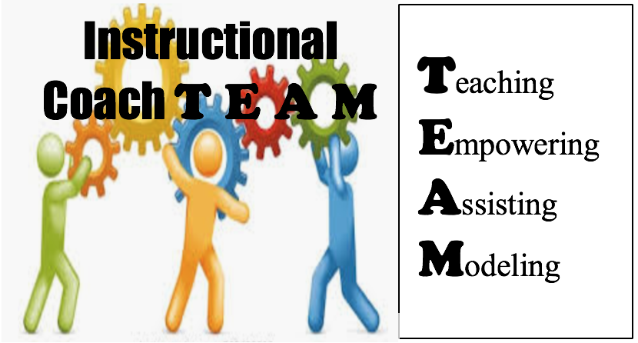

Instructional Coaches will continue to meet the 3rd Thursday afternoon of every month except December and May
(See dates on page 16.)

The 3 major focuses of IC sessions will be to:
1. Continue to equip ICs with strategies, schedules, and workloads that allow them be in classrooms as well as mentoring, modeling, and coaching teachers.
2. Equip ICs with the tools, strategies, and best practices needed to coach PreK-12 teachers in the process of incorporating The Science of Reading as well as the best practices of teaching students to conceptualize/rationalize the math as opposed to teaching them to simply memorize the math.
3. Instructional Coaches will embark on the journey of understanding and utilizing the requirement of leadership in coaching.
Other professional learning will include an in-depth look at Scarborough’s Reading Rope and the book, Shifting the Balance. This work will require you to lead the work.

Date | Who | Time | Topic | Evidence
July 2021 | Principals |  | J. Dyar presents ESOL info to principals for upcoming year. | Sign in Sheet | Face to Face
July/August 2021 | Instructional Coaches |  | ESOL info to ICs | Sign in Sheet | Face to Face
8.04.2021 | ESOL teachers | 8am-4pm | ESOL Back to School/Project EL PD | PPTX  Sign in sheet | Face to Face
8.05.2021 | PreK Teachers | 9am-10am | Resources for teaching Pre-K English learners | Invitation, SIgn In Sheet, PPTX | Virtual through Google Meets
8.05.2021 | Academic teachers | 10:30-11:30 | ACCESS Scores  Can Do Descriptors  Parent Communication | Invitation, Sign In Sheet, PPTX | Virtual through Google Meets
August-May | Offered to All Certified Staff/Admin |  | WIDA Virtual PD Sessions | Certificate of Completion | Virtual through WIDA platform
August/September 2021 | ICs in Schools |  | Plan and Conduct ESOL PLC for the building | Agenda, Sign in Sheet etc.. | Face to Face
9.8.2021 | ESOL teachers | 3:15-4:00pm | CoTeaching for English learners/Virtual Strategies/EL-TPC refresher | Invitation, Sign In Sheet, PPTX | Virtual through Google Meets
9.14.2021 | Academic teachers | 3:15-4:00pm | Strategies You can Use - Utilizing Resources available to you | Invitation, Sign In Sheet, PPTX | Virtual through Google Meets
10.5.2021 | ESOL teachers | 3:15-4:00pm | Book Study – To Be Determined by ACCESS scores/Survey Results | Invitation, SIgn In Sheet, PPTX | Virtual through Google Meets
11.9.2021 | ESOL teachers | 3:15-4:00pm | Book Study | Invitation, SIgn In Sheet, PPTX | Virtual through Google Meets
1.04.2021 | ESOL teachers | 3:15-4:00pm | Book Study | Invitation, SIgn In Sheet, PPTX | Virtual through Google Meets
2.15.2021 | ESOL teachers | 3:15-4:00pm | ACCESS orientation | Invitation, SIgn In Sheet, PPTX | Face to Face
3.8.2021 | ESOL teacher | 3:15-4:00 | Book Study Wrap up | Invitation, SIgn In Sheet, PPTX | Google Meets
April/May | ICs to Staff |  | ESOL PLC 2 for schools
5.26.20021 | ESOL teachers | 9:00-11:30 | ACCESS Score Dissemination, Planning for FY 23, FY22 Reflection | Invitation, SIgn In Sheet, PPTX | In Person
Late April/May | ESOL PD Survey |  | District Wide | Survey Results | Via Email

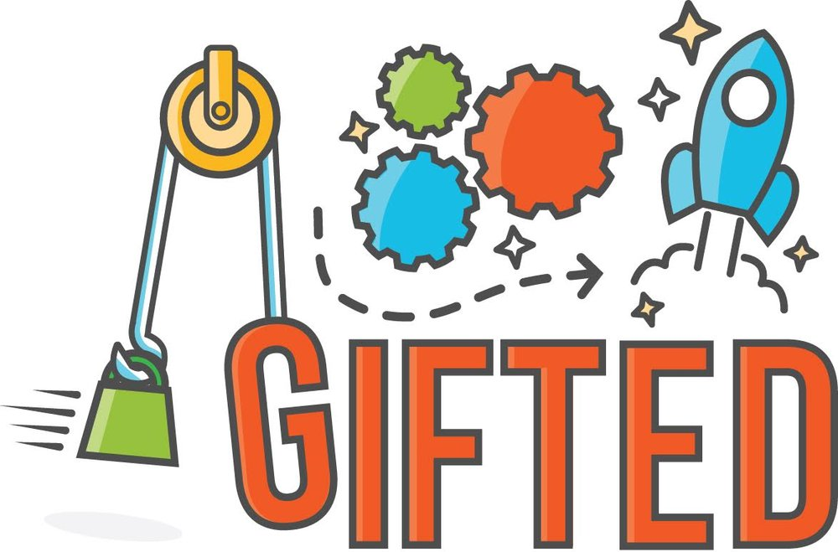
Gifted

Gifted PD will be offered through state offered webinars. Gifted Virtual Specialists will be offering sessions on Advanced Content and Student Engagement via live webinars. Recordings will also be available after the live presentation. Dates will be communicated once determined by the state department. School level gifted teachers and coordinators will be asked to participate either live or by watching the recorded webinars.

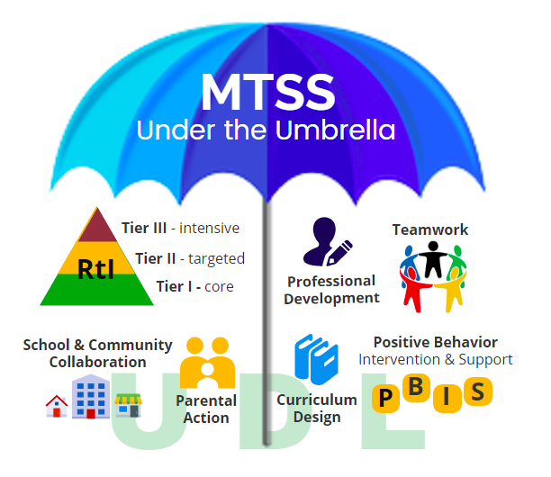
MTSS

As our district implements Go MTSS/SST through SLDS, trainings will be offered to various
staff members in entering data and tracking the SST process. This will be completed to ensure the SST process is followed per Georgia requirements.

Multiple trainings are being offered by the state department for MTSS professional development throughout FY 22. As needed, these trainings will be reviewed and discussed by MTSS contacts and the district coordinator prior to sharing with staff.

PBIS and MTSS for Behavior

Trainings will be held to share state recommended sessions for improving PBIS initiatives within the schools. Trainings could be in person or virtual.

At minimum, the PBIS school coach will participate in coach meetings with the district coordinator quarterly.

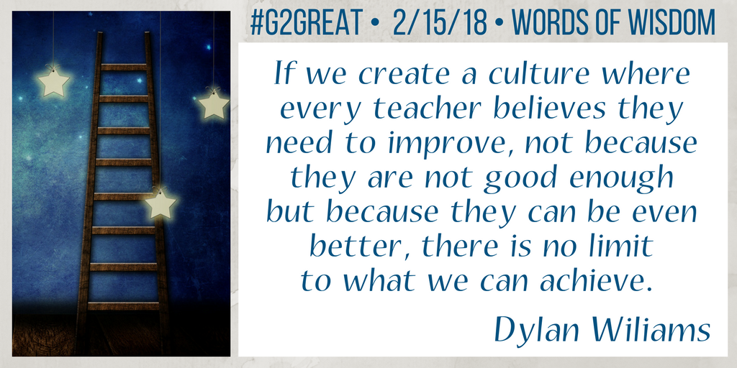

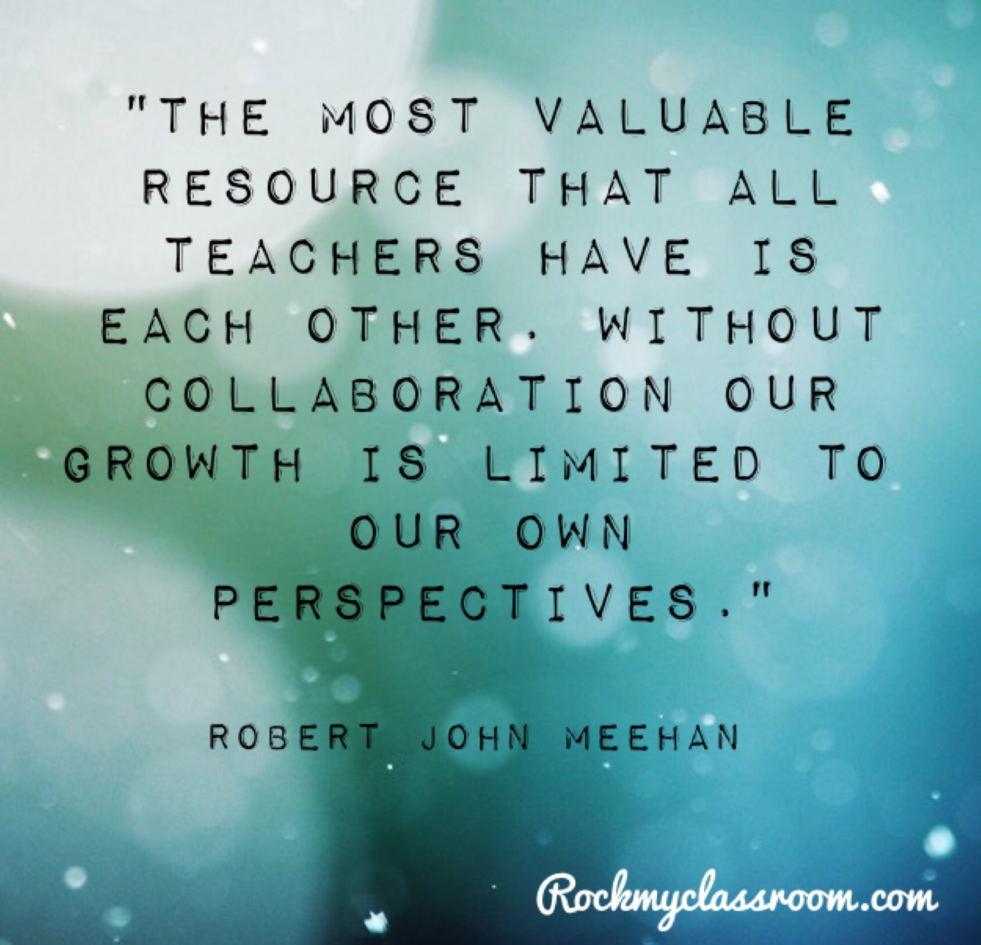
 | Principals Monthly Meeting | Asst. Principals Meeting | Instructional Coaches | Aspiring Leaders Cohort 6 | Media Specialists Meeting | Laurens County PLC Sessions
August | 16  NWL | 19  8:30 am | 19  1:00 pm |  | 30th 1:00 ELMS
September | 20  ELM | 30  8:30 am | 30  1:00 pm |  |  | Introduction  Elementary: Teaching Reading is Rocket Science  M/HS: Bridging the Gap Between Literacy and Content
October | 18  WLM | 21  8:30 am | 21  1:00 pm |  | 25th 1:00  ELPS | Elementary: Phonemic Awareness- It All Starts Here  M/HS: Language Comprehension: Background Knowledge
November | 15  BOE | 18  8:30 am | 18  1:00 pm | 8:30-3:30 |  | Elementary: Phonics: Just Do It-Explicitly and Systematically  M/HS: Language Comprehension: Vocabulary Knowledge
December | 14  Breakfast BOE 7:00
January | 18  ELP | 20  8:30 am | 20  1:00 pm | 8:30-3:30 | 31st 1:00  SWLE | Elementary: High Frequency Words: Don’t Confuse Memorizing with Learning  M/HS: Language Comprehension: Language Structures
February | 15  WLH | 17  8:30 am | 17  1:00 pm |  |  | Elementary: Cueing Systems: What to Do When a Kid Gets Stuck  M/HS: Language Comprehension: Verbal Reasoning and Literacy Knowledge
March | 21  SWL | 24  8:30 am | 24  1:00 pm | 8:30-3:30 |  | Elementary: Language Comprehension: The Power of the 5 Strands  M/HS: Word Recognition: Phonemic Awareness, Phonics, and Sight Recognition
April | 18  ELE | 21  8:30 am | 21  1:00 pm |  | 25th 1:00 NWLE
May | 16  ELH |  |  | 8:30-3:30

District PLC Sessions

“In order for the power of these district PLC sessions to be fully demonstrated, the learning must be infused in school level PLC sessions, grade level/department meetings, walkthroughs, and coaching, as opposed to the session being presented in isolation.”

The Why:
To equip teachers with new, scientifically based learning, practices, and tools that will empower all students to be successful readers in all content areas.

The How:
Elementary Sessions:
Introductory Session: Small Shifts, Big Impacts
The Why, The How, Bringing the Science of Reading into the
Balanced Literacy Classroom
Phonemic Awareness: It All Starts Here
Phonics: Just Do It-Explicitly and Systematically
High Frequency Words: Don’t Confuse Memorizing with Learning (Mapping)
Cueing Systems: What to Do When a Kid Gets Stuck
Language Comprehension: The Power of the 5 Strands

Middle and High School Sessions:
Introductory Session: Bridging the Gap Between Content and Literacy
The Why, The How, & Building the Reading Rope
Language Comprehension: Background Knowledge
Language Comprehension: Vocabulary Knowledge
Language Comprehension: Language Structures
Language Comprehension: Verbal Reasoning and Literacy Knowledge
Word Recognition: Phonemic Awareness, Phonics, and Sight Recognition

