The growth and development of people is the highest calling of leadership. ~Harvey Firestone

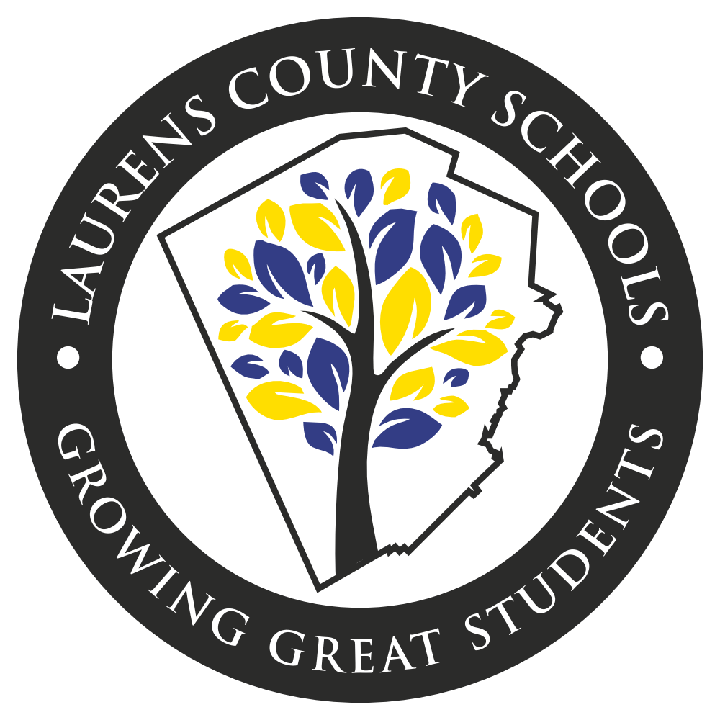

Laurens County School District
Professional Learning Plan FY20

Table of Contents

The Students Success Model…………………………………………………………………….3
Definitions of a Professional Learning Community……………………………...……………3-5
Laurens County School Professional Learning Groups……………………………..…………..6
Aspiring Leaders………………………………………………………………………………..7
Assistant Principals Professional Development………………………..……………………….8
District-Wide Alignment………………………………………….……………………………9
Media Specialists Community of Learners…………………………………………………….10
Professional Learning for Teachers of Gifted, LMB, and SPED………………………………11
District-Wide Professional Learning Dates…………………………………………………….12

DISTRICT IMPROVEMENT GOALS
To increase number of students reading on grade level based on Lexiles
Increase percentage of students scoring at proficient and distinguished levels on the GMAS
To close the achievement gaps within the subgroups.
Increase and/or maintain school climate ratings at each school.
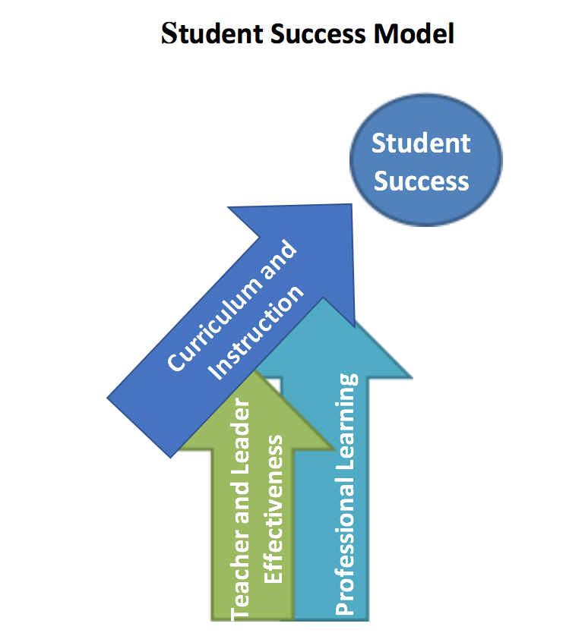

The Georgia State Board of Education defines Professional Learning as: “the means by which teachers, administrators and other school and system employees acquire, enhance and refine the knowledge, skills and dispositions necessary to create and support high levels of learning for all students.” This definition defines students’ success as the ultimate outcome of intentional and purposefully planned professional learning. The vital role of professional learning is more clearly illustrated with the following graphic borrowed from the Kentucky Department of Education.
Professional learning occurring within a LUA or any organization that requires employees to be certified will be job-embedded and will take place within a Professional Learning Community (PLC). The PLC will be the primary vehicle for professional learning. PLCs operate under the assumption that the key to improved learning for students is continuous job-embedded learning for educators (2015). (Retrieved from “All Things PLC” http://www.allthingsplc.info/about.) Workshops, when needed, will support the work of job-embedded professional learning done within learning communities, not replace it.
1. Engaging in professional learning on a continuing basis by fully participating in the LUA’s professional learning community as documented by the educator’s supervisor and described in GaPSC Guidelines accompanying this rule;
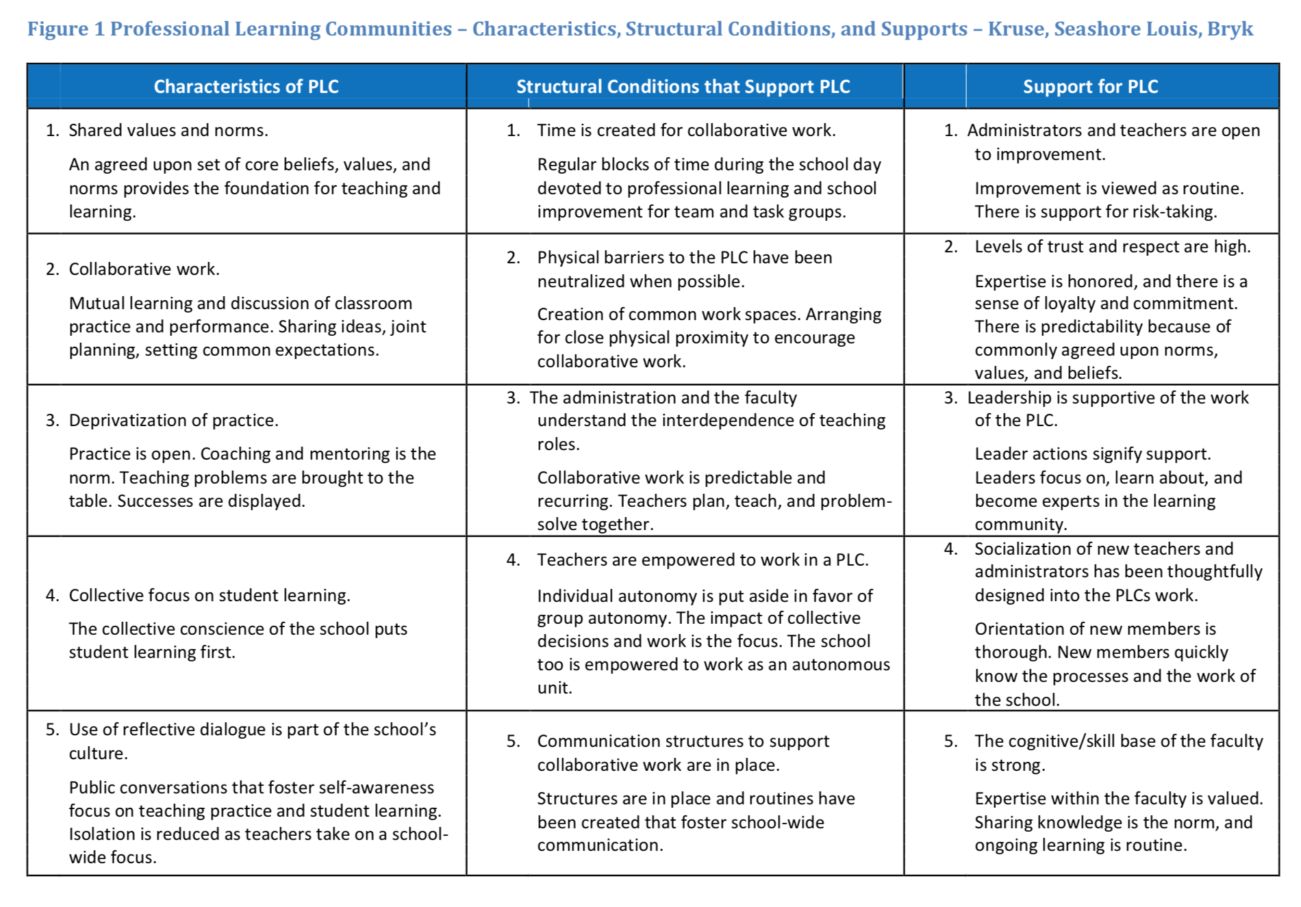
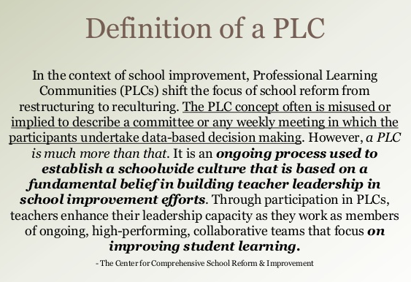

“Turning Best Practice into Common Practice”
In the Laurens County School System, a Professional Learning Community is who we are as a result of several efforts to build a community of learners and where we strive to make best practice, common practice.

In FY20, Laurens County Schools will continue the transitioning PLCs to be more teacher-led. In continuing the established protocols and norms set in 2016, the PLCs will continue to be engaging and participatory as opposed to simply receiving information or participating in a faculty meeting.

The 2019 PLC Survey results revealed a desire to further differentiate PLCs for the different content areas and support service staff. Faculty and staff professional learning goals (in the TKES platform) and peer coaching should also be incorporated into the school’s professional learning plan.

Topics for District PLCs: Using DIBELS Data, Lexiles, Instructional Technology, CCRPI for Teachers, MTSS, Strategies for ESOL Learners, Mathematics for middle and HS, and Mental Health including Social and Emotional needs.
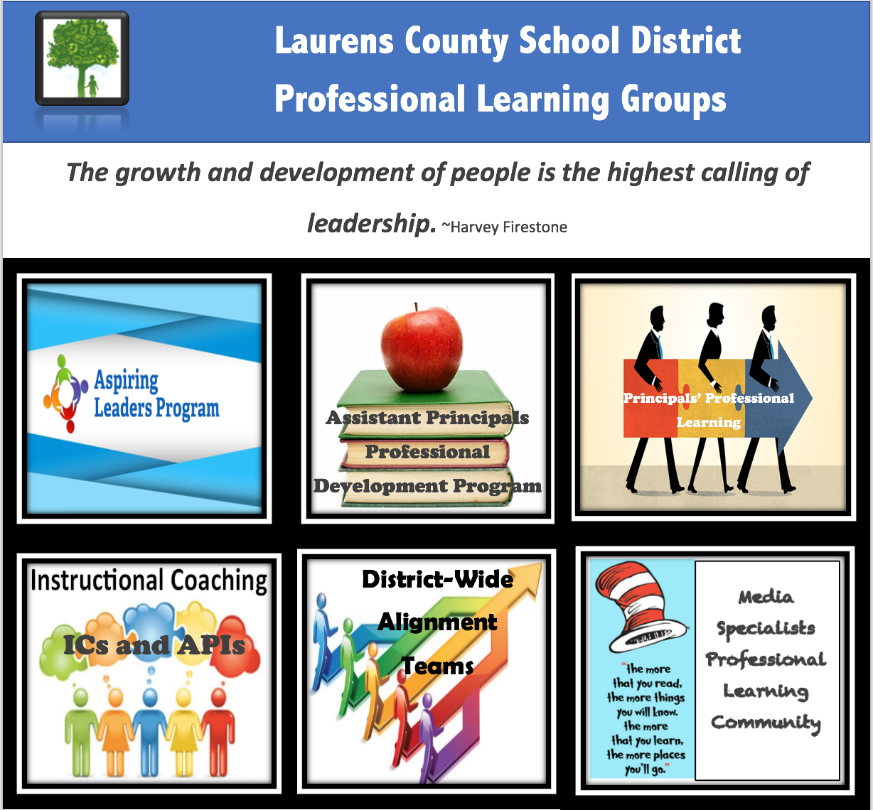

New

Budgeting and Personnel
Organization Management
Accountability
Curriculum, Instruction, and Assessment

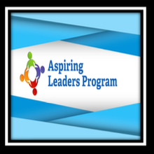

Aspiring Leaders Cohort 5

October 24, 2019
Program Overview and Requirements
Why Be A Leader?
21 Irrefutable Laws of Leadership
Leader Styles and Qualities
LKES Overview
The Butterfly Effect

January 23, 2020
Word Cloud Presentation
Infomercial Book Study
CCRPI for Leaders

March 26, 2020
School Finance and Budgeting
Growth Mindset for Leaders

May 26, 2020
Infomercial Book Study Presentations
Interview Tips Activity
Final Leadership Advice

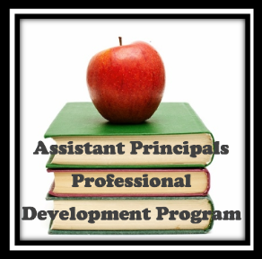

LKES 2 School Climate
The leader promotes the success of all students by developing, advocating, and sustaining an academically rigorous, positive, and safe school climate for all stakeholders.
LKES 7 Professionalism
The leader fosters the success of students by demonstrating professional standards and ethics, engaging in continuous professional development, and contributing to the profession.
LKES 8 Communication and Community Relations
The leader fosters the success of all students by communicating and collaborating effectively with stakeholders.

Asst. Principals Meeting
September 19, 2019-LKES Standard 2-School Climate
November 21, 2019-LKES Standard 7-Professionalism
January 16, 2020 Training with Aspen
March 19, 2020 Scheduling Creation in Aspen
May 21, 2020-LKES Standard 8-Communication & Community Relations

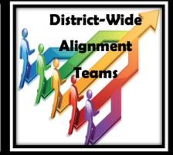

Laurens County recently began an epic journey to improve the instructional delivery for our students called District Wide Alignment (DWA). The vision of the Laurens County DWA teams is to develop curriculum maps and unit benchmarks that are aligned to those curriculum maps. These maps and benchmarks are 100% designed and vetted by Laurens County teachers. They own them. The purpose of the DWA is to level instruction for all Laurens County students. We believe that if a student attends any school in our county, they should receive the same quality education in the same scope and sequence. Not only do our teams develop comprehensive curriculum maps but they also spend quality time aligning standards to proper rigor levels. The alignment of district bought instructional resources to the LCSS curriculum map is also a goal of the DWA teams.

At present, the Grades K-6 ELA team have completed their initial curriculum maps and are working to add embedded writing instruction to the map. The Grades 4-12 Math teams have completed their curriculum maps and are working to put unit benchmarks into the Performance Matters platform for all teachers to use.

Future plans for the FY20 school year are to continue with DWA by including other grades and subject areas. We will begin with K-3 Math and 6-12 ELA alignment. This will occur during Semester 1 of FY20. After Christmas Break, we plan to align Science and Social Studies curriculum.

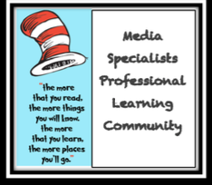

Media Specialists Meetings

August 29, 2019

October 29, 2019

February 27, 2020

April 23, 2020

A great amount of the professional learning for media specialists will be focused on further development of the new services and resources provided in our media centers. A laser focus will continue to be placed upon making the media centers more relevant for today’s learners and today’s teachers. In the initial session, media specialists will also provide input into what they would like to see provided in their professional learning community sessions.

Monthly Gifted Education Professional Learning will utilize a hybrid approach of train the trainers (school level gifted coordinators to redeliver) and also direct professional learning from the coordinator.

Lindamood Bell Professional Learning
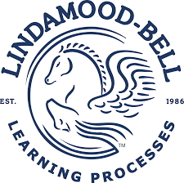
Twenty-five additional teachers were trained this summer. This is meeting the established goal of further expanding the opportunities for more students to be able to learn to read or improve their reading abilities through the Lindamood Bell (LMB) processes. In FY19, the opportunities for students to learn with the LMB processes were no longer isolated to students with special needs. In FY20, LMB will be expanded even further into WIN groups and in the regular classroom setting.

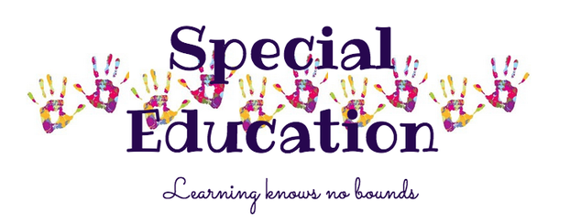
To assist with the goal of further differentiating PLC sessions for specific content and teaching assignment needs, the Special Education department has created the following sessions and professional learning opportunities. PLCs will be 3:30pm to 4:30pm
a. ELP/ELE at ELE - Sept 3, Oct 8, Nov 12, Jan 14, Feb. 18, March 24, April 28
b. ELM/ELH at ELM - Sept 5, Oct 10, Nov 14, Jan 16, Feb 20, March 26, April 30
c. NWL – Sept 9, Oct 21, Nov 18, Jan 27, Feb 24, March 30, May 4
d. SWL – Sept 10, Oct 15, Nov 19, Jan 21, Feb. 25, March 31, May 5
e. SGA/WLM/WLH at WLM – Sept 12, Oct 17, Nov 21, Jan 23, Feb. 27, April 2, May 7
f. Make up sessions (location TBA) - Sept 16, Oct 22, Nov 20, Jan 28, March 2, April 1, May 11
3 Day Summer Training for ABA with Dr. Dana Zavatkay
Co-teacher training will Allison Oxford consisting of a one-day summer session and individual school visits throughout the school year.
New SPED Teacher Training July 30, 2019
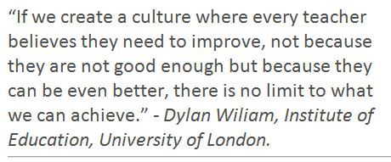
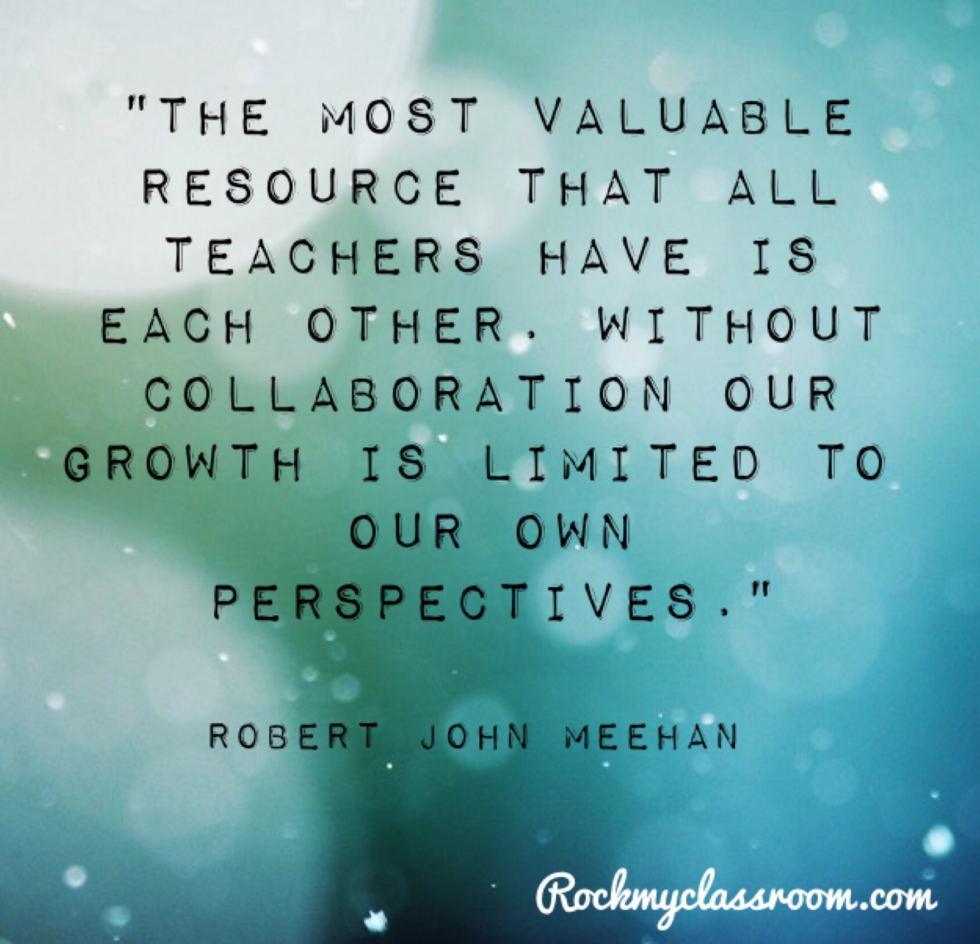
 | Principals Monthly Meeting | Asst. Principals Meeting | Instructional Coaches/APIs | Aspiring Leaders Cohort 5 | Media Specialists Meeting | Laurens County PLCs
August | 13-Aug |  | 15-Aug |  | 29-Aug-19
September | 17-Sep | 19-Sep | 19-Sep |  |  | Learning Even More with Lexiles
October | 15-Oct |  | 17-Oct | 24-Oct | 29-Oct-19 | CCRPI for Teachers
November | 19-Nov | 21-Nov | 21-Nov
December | 17-Dec
January | 14-Jan | 16-Jan | 16-Jan | 23-Jan |  | Success with MTSS
February | 18-Feb |  | 20-Feb |  | 27-Feb | Instructional Technology
March | 17-Mar | 19-Mar | 19-Mar | 26-Mar
April | 14-Apr |  |  |  | 23-Apr | Students' Social and Emotional Needs
May | 19-May | 21-May | 21-May | 26-May-20

