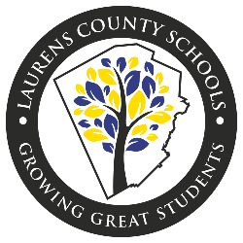
Laurens County School District
Primary Instructional
Materials and Resources

Primary School Level Kindergarten through 2nd Grade

ELA/Social Studies-
IREAD
Scholastic Guided Readers
Studies Weekly
ReadyGEN
IXL

Math-
IXL Math
Into Math

Science-
Appropriation Budget for Classroom Materials
Aims Units

Cross-Curricular-
Headsprout

Read 180, System 44, and Math 180 are instructional resources used within our RtI program for various grade levels.

Elementary School Level 3rd through 5th Grade

ELA/Social Studies-
ReadyGEN
Scholastic Guided Readers
Reading Inventory (Scholastic)
Studies Weekly
IXL

Math-
IXL Math
Into Math

Science-
Appropriation Budget for Classroom Materials
Aims Units

Cross-Curricular-
Headsprout

Read 180, System 44, and Math 180 are instructional resources used within our RtI program for various grade levels.

Middle School Level
ELA/Social Studies-
Reading Inventory (Scholastic)
Windows and Mirrors ELA Resource
McGraw-Hill 6th and 7th Grades
Gallopede
IXL

Math-
McGraw Hill
IXL Math

Science-
Pearson Science

Read 180, System 44, and Math 180 are instructional resources used within our RtI program for various grade levels.

High School Level
ELA/Social Studies-
Reading Inventory (Scholastic)
Mirrors & Windows EMC
Pearson US History, World History, Government
HMH Economics
IXL

Math-
IXL

Science-
Pearson Science
McGraw-Hill Physical Science

Cross-Curricular-
Edgenuity

Spanish-
Pearson Realidades

Read 180, System 44, and Math 180 are instructional resources used within our RtI program for various grade levels.

