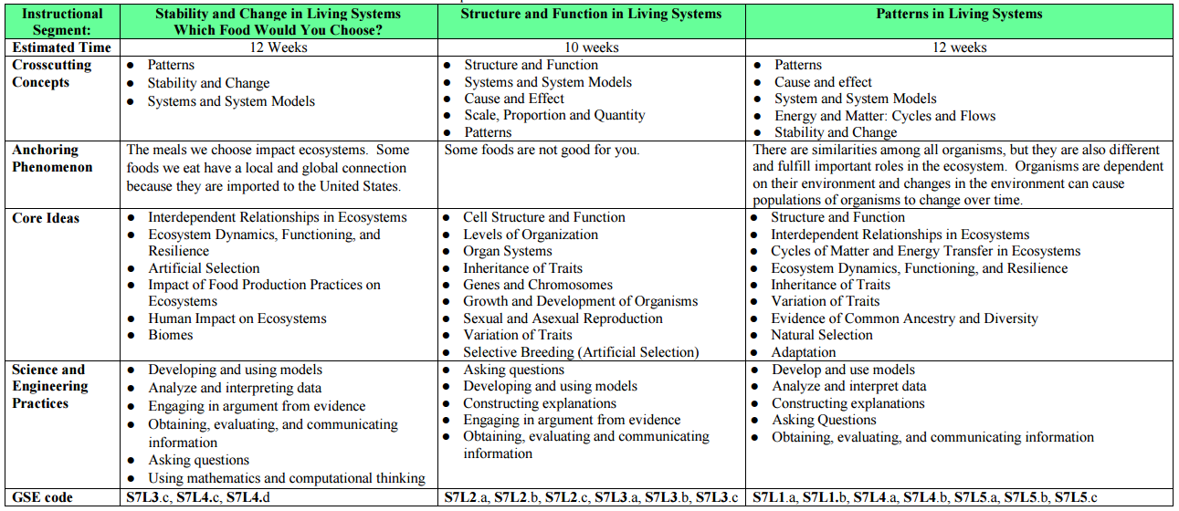



**Laurens County Schools 7th Grade Science Curriculum Map**