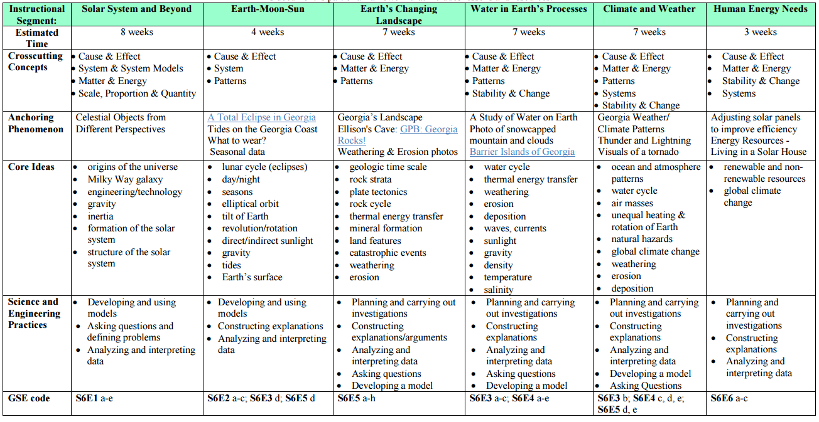



**Laurens County Schools 6th Grade Science Curriculum Map**